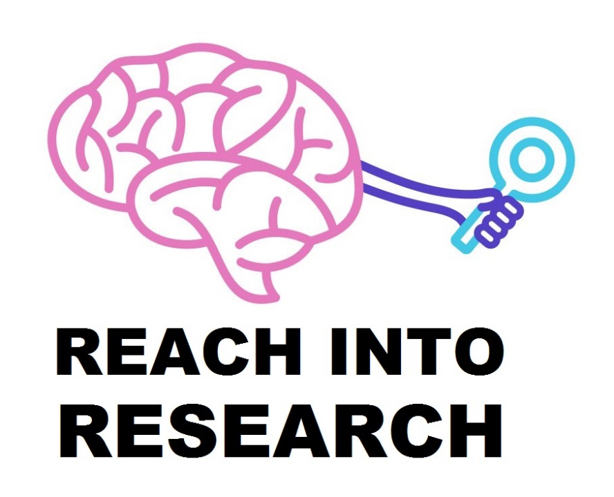

Curing Cancer with the Wave Properties of LightHow the Energy of Light is Transferred to Gold Nanoparticles to Kill Cancer

Curing Cancer with the Wave Properties of Light

Purpose
The purpose of this lesson is to teach students that light is an electromagnetic wave and electromagnetic waves move charged particles, thus transferring energy to the charge particles. They will also learn about resonance of vibrating objects. They will learn how these concepts apply to treating cancer with gold nanoparticles.

Audience
This lesson was designed to be used in an introductory high school physics course.

Lesson Objectives
Upon completion of this lesson, students will be able to:
- Sketch the wave nature of light and describe why light moves electrons.
- Define the natural frequency of a vibrating object, driving frequency and resonance.
- Demonstrate and explain why the driving frequency must approximately match the natural frequency to lead to the largest amplitude and fastest oscillations of a spring. Use this to explain why a particular frequency of light is needed for gold nanoparticles to be most effective therapeutically.
- Describe how the gold nanoparticle cancer treatment works.

Key Words
driving frequency, photothermal therapy, nanoparticle, natural frequency, resonance

Standard Alignments

Science and Engineering Practices

SP 6. Constructing explanations

MA Science and Technology/Engineering Standards (2016)
  - HS-PS4-5. Communicate technical information about how some technological devices use the principles of wave behavior and wave interactions with matter to transmit and capture information and energy

NGSS Standards (2013)
  - HS-PS4-5. Communicate technical information about how some technological devices use the principles of wave behavior and wave interactions with matter to transmit and capture information and energy

Primary Sources
Rastinehad, Ardeshir R., Harry Anastos, Ethan Wajswol, Jared S. Winoker, John P. Sfakianos, Sai K. Doppalapudi, Michael R. Carrick, Cynthia J. Knauer, Bachir Taouli, Sara C. Lewis, Ashutosh K. Tewari, Jon A. Schwartz, Steven E. Canfield, Arvin K. George, Jennifer L. West, and Naomi J. Halas. “Gold Nanoshell-Localized Photothermal Ablation of Prostate Tumors in a Clinical Pilot Device Study.” Proceedings of the National Academy of Sciences (2019). doi:10.1073/pnas.1906929116.
Amendola, Vincenzo, Roberto Pilot, Marco Frasconi, Onofrio M Maragò, and Maria Antonia Iatì. “Surface plasmon resonance in gold nanoparticles: a review.” J. Phys.: Condens. Matter 29 (2017). https://doi.org/10.1088/1361-648X/aa60f3.
Biagioni, Paolo, Jer-Shing Huang, and Bert Hecht. “Nanoantennas for Visible and Infrared Radiation.” Reports on Progress in Physics (2012). doi:10.1088/0034-4885/75/2/024402.

Materials
- A copy of the Student Handout for each student
- 1 red finger light and 1 green finger light. (Alternatively, you can use a red laser pointer and a green laser pointer. Students can take turns trying the lights, so it suffices to have only 1 green light and 1 red light for the entire class).
- Have the following materials for every pair of students (or for every group of four students if not enough supplies are available to do the activity in pairs):
- 1 spring (spring constant 2.5 or 5 N/m)
- Mass (use about 125 g or 250 g for springs with spring constants of 2.5 or 5 N/m, respectively)
- 1 meter stick
- Duct tape or masking tape
- 1 stopwatch
- Safety goggles (if desired)

Time
This lesson should take approximately one 50-minute class period.

Student Prior Knowledge
Students should know what the frequency of a wave is. Students should preferably be familiar with the concepts of electric and magnetic fields. Students should preferably know that a higher temperature means the molecules are moving faster.

Instructions and Teacher Tips
- General Procedure
  - Provide all student pairs (or groups of 4) with one spring and the corresponding mass (125 g or 250 g for a spring with a spring constant of 2.5 or 5 N/m, respectively). If the springs come with hooks, be sure to secure the hook to the spring with tape since the hooks are prone to falling off. Have the students work through the spring activity and question sheet, which will take 35 minutes.
  - Tell students that after completing the spring activity, they should come to your desk to do the red light/green light activity. This activity can be done with a small green light and red light, or a low power green laser pointer and red laser pointer. First explain the following to the students:
  - For the most part, visible light cannot pass through your body. You know this! Your body is not like glass that lets light through. (The light gets absorbed by pigment molecules in our body). That raises a problem: When the nanoparticles are inside a person, visible light can’t get into the body to hit the nanoparticles, so how can we use the nanoparticles to treat cancer? We can use infrared light instead. Infrared light can pass through our bodies. Infrared light is just like visible light only it has a slightly longer wavelength, and our eyes can’t see infrared light.
  - The procedure is the following: Turn on the green light and completely cover it with the tip of your finger (use the part of your finger where your fingerprint is). Now look at the back of your finger. You’ll see that almost no light passes through your finger.
  - Repeat the step above but use the red light instead. You’ll see that the red light is partially blocked by your finger, but more red light can pass through your finger than green light could.
  - Tell the students that infrared light has a slightly longer wavelength than red light and can pass through your body even better than red light. Researchers have made nanoparticles that undergo resonance when exposed to infrared light. When treating the patients with gold nanoparticles, the researchers shine infrared lasers on the patients. The wavelength of the laser is 800 nm. If desired, have the students calculate the frequency of the laser light.

Additional Background Information
- Different researchers using different shaped nanoparticles. The ones used in the clinical trial were spheres of gold with a silica core inside. Other cancer researchers have used rod-shaped particles (nanorods) of gold or other shapes. All these nanoparticles undergo oscillations of their electrons, and different shapes undergo resonance when exposed to different frequencies of light. Through a comparison of a mathematical model to experimental data, the nanorods have been shown to be very much like springs, with the electrons oscillating toward one end and then back toward the other end, just like a spring oscillating up and down. Therefore we focus on nanorods in the lesson since they are the most similar to springs.

Answers
Hold the spring close to the meterstick and let the mass dangle down. With a piece of tape, mark the meterstick at the spot where the mass is dangling down – this is the mass’s resting position. While holding the top of the spring still, pull the mass down by 5 cm away from its resting position and let the mass go. Count the number of oscillations that occur in 10 seconds. (Note: One oscillation is when the mass goes from the lowest point to the highest point and back to the lowest point). You should have one person count the oscillations while the other person looks at the stopwatch. The stopwatch person should start the stopwatch as soon as the other person lets go of the mass.
- Based on the number of oscillations you counted, what is the frequency of oscillation?
0.7/second (when using a spring constant of 2.5 N/m and mass of 0.125 kg)
- What is the amplitude of oscillation (i.e. how far from the resting position does the mass go)?
5 cm
Repeat the above steps, but this time pull the mass down by 10 cm and let it go.
- What is the frequency and amplitude of oscillation this time?
0.7/second (when using a spring constant of 2.5 N/m and mass of 0.125 kg)
- Why doesn’t it take longer for the mass to make a full oscillation when you pull it down further? (Hint: the mass is not moving at a constant speed. Think about acceleration).
When pulled more, the mass accelerates more and so it goes faster. It goes a larger distance at a larger speed, so it takes the same amount of time as going a shorter distance at a lower speed.
Every vibrating object (such as a spring or a guitar string) has its own frequency at which it always oscillates after you pull it and then let it go. This is called its natural frequency. The natural frequency depends on the object. For example, stiffer springs oscillate faster (i.e. have a larger natural frequency) than looser springs. For a particular spring, it doesn’t matter how far you pull the spring, when you let it go, it will always oscillate at the same frequency. The same is true for other oscillating objects.

Nanoparticles come in different shapes, including elongated particles called nanorods. Gold nanorods behave much like springs (see Figure 1): after the electrons are pushed toward one end, the electrons swing back toward the other end and keep going back and forth at a particular frequency, like a natural frequency in springs.

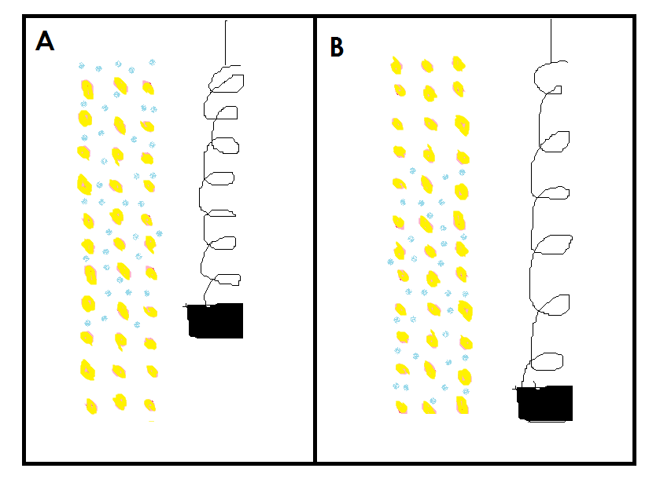
Figure 1: Gold Nanorods are like Springs. The gold atoms are shown in yellow. (A) shows the electrons (shown in blue) near the top end, like a mass on a spring that has gone up. {B) shows the electrons near the bottom end, like a mass on a spring that has gone down.

Now you will use the spring to understand in detail what happens to electrons in a gold nanoparticle when they are exposed to light. This time, you won’t pull the mass down and let it go. Instead, you will repeatedly move the top of the spring up and down. When you move up, the spring pulls the mass upward. When you move down, the spring pushes the mass downward. This is similar to how the light wave’s electric field pushes the electrons up and down in the gold nanoparticle.

The spring can move a lot, so put on safety goggles and hold the spring far from your face so it does not hit you. Hold the spring high above the floor so it does not hit the ground. Repeatedly move the top of the spring up and down at the frequency you wrote down in question 1 (i.e. the natural frequency). When moving the top of the spring, move it up to 2 cm above its starting position and then down to 2 cm below its starting position and repeat this about 10 times in a row - in other words, do 10 oscillations. (You can watch the stopwatch to make sure you are approximately moving the spring at the right frequency). Notice how your hand is moving in sync with the mass. Also notice how even though you are only moving your hand 2 cm in either direction, the mass eventually moves much more than 2 cm.
- What is the final amplitude of oscillation? (Measure from the resting position down to the lowest point where the mass went).
Big! About 60 cm (when using a spring constant of 2.5 N/m and mass of 0.125 kg)
The frequency at which you are moving the top of the spring up and down is called the driving frequency because you are driving (forcing) the spring. Repeat the previous step three times, but each time move the top of the spring at a different frequency. Use the following driving frequencies: twice the natural frequency, three times the natural frequency, and half the natural frequency. Carefully observe the motion of your hand, the spring and the mass.
- For each driving frequency, what is the final amplitude of oscillation?
For twice the natural frequency: Amplitude is about 5 cm
For three times the natural frequency: Amplitude is about 1 cm
For half the natural frequency: Amplitude is 2 cm
- a. Which driving frequency gave rise to the greatest amplitude of oscillation?
The greatest amplitude occurs when the driving frequency is the same as the natural frequency.
b. Notice how this driving frequency caused the mass to move the largest distance every second - in other words, it caused the mass to have the largest speed. Explain why this driving frequency led to the greatest amplitude and speed. (Hint: Watch the mass as you push the spring, and compare your hand’s motion and the mass’s motion). Drawings/diagrams are the best way to explain science. Draw a quick diagram along with your written explanation.
This is because your hand is in sync with the motion of the mass. When the mass is going up, your hand is also going up, so you accelerate the mass up. When the mass is going down, your hand is also going down, so you accelerate the mass down. Therefore, you are always working with the mass, not against it, and so you increase the mass’s speed and displacement from its resting position. (If your hand were to go up while the mass were moving down, you would decelerate the mass and so the mass would move less).
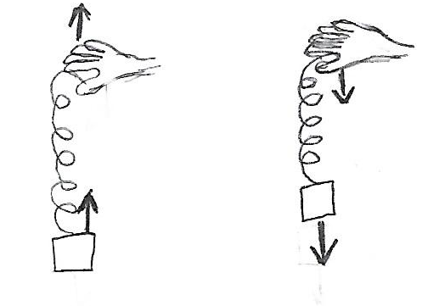
- Which driving frequency gave rise to the smallest amplitude and slowest speed? How come?
The driving frequency that is 3 times the natural frequency gave the smallest amplitude. This is because whenever you would move your hand up, you would immediately move your hand back down, so you keep reversing the direction of the force you exert on the mass so fast that the mass never has time to accelerate.
- As you saw, a particular driving frequency caused the spring to have a large amplitude. We call it resonance when an oscillating object has a large amplitude as a result of being pushed by a particular frequency. The electrons in gold nanoparticles also experience resonance. Use your understanding of springs, gold nanoparticles and light to answer the following question. For parts a and b, draw quick diagrams along with your written explanations.
a. Why do the electrons in a gold nanorod oscillate with the largest amplitude and largest speed when they are exposed to light with a frequency that is the same as the natural frequency of the electrons’ oscillation?
The frequency of the light is such that the light pushes and pulls in sync with the natural oscillation of the electrons in the nanoparticles, so the electrons will accelerate the most.
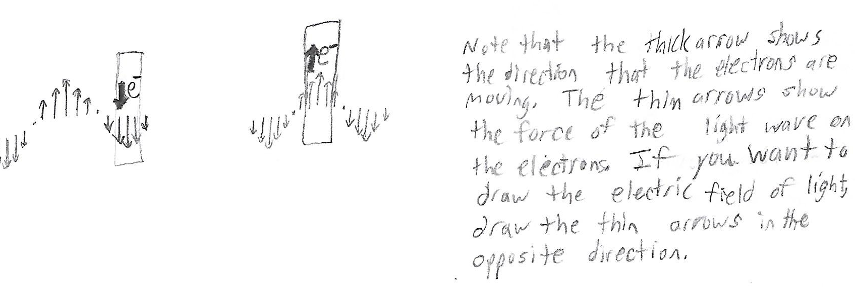

b. Why is it important to make the electrons move as fast as possible when treating cancer?
Having fast electrons will cause the proton to move fast upon colliding with the electrons, which will cause nearby molecules to move fast. This means the cancer will heat up the most, which will kill the cancer.
