Curing Cancer with the Wave Properties of LightHow the Energy of Light is Transferred to Gold Nanoparticles to Kill Cancer

Curing Cancer with the Wave Properties of Light

Introduction
First read this introduction, and then do the activity below.
Before we get to curing cancer, we will ask the question “What is light?” What is this bright thing that you can’t grab hold of? Light is actually just an oscillating force that moves through space (May the oscillating force be with you!). This is probably very surprising to you, so let’s dive deeper.
Picture a seagull floating on the ocean. When a wave comes by, it makes the seagull bob up and down. Light is like this, but different. Rather than affecting seagulls, light is an oscillating force that makes charged particles, such as electrons and protons, bob up and down (or move from side to side). This force moves out from where it was created (in the sun or a lightbulb), and when it reaches a charged particle, the force pushes the charged particle up and down. Light is a wave, but it is different from ocean waves. Ocean waves involve water moving up and down, but light does not actually move up and down in a wavy shape. Rather, light is a wave in the sense that it fits the scientific definition of a wave: a disturbance that moves through space, causing something to increase and then decrease as it passes. Ocean waves fit this definition because they cause the height of the water to increase and decrease. Light fits the definition of a wave because it is a force that increases and decreases (the force even changes direction as it goes). Figure 1 shows the force of light. The length of the arrow indicates how much force there is. The longer the arrow, the greater the force.
To be more specific, we should emphasize that light is not just any force. Light specifically is forces that push on charged particles. Such forces are called electric fields and magnetic fields (see Figure 1). In a light wave, the magnetic field is actually much weaker than the electric field, so we will ignore the magnetic field and pay attention only to how the electric field pushes on the charged particles.
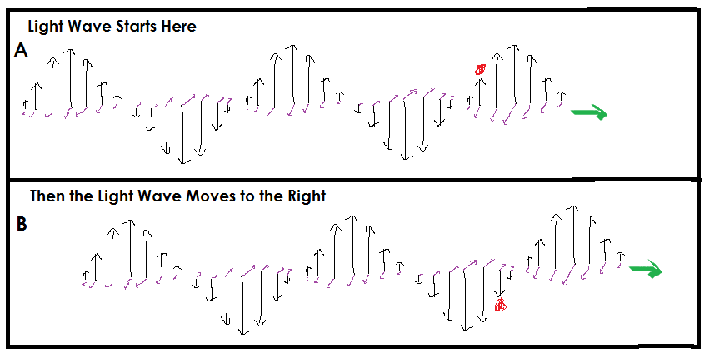

Figure 1. Light Wave. (A) Light is a wave of electric fields (shown by the black arrows) and magnetic fields (shown by the purple arrows), which are perpendicular to the electric fields. The green arrow shows the direction that the wave is traveling (the light wave travels at the speed of light, of course!). First we show the light wave at one moment in time. (B) Next we show the light wave a very short time later. The red dot is a positively charged particle which at first is being pushed up by the wave and then is being pushed down by the wave.
Now let’s talk about a new treatment for cancer and how light is an important part of it. Researchers are injecting microscopic pieces of gold into patients. These gold pieces are about 100 nanometers long (a nanometer is one billionth of a meter) and are called gold nanoparticles (yes, it is not a very creative name). The gold nanoparticles float through the patient’s bloodstream. This is where it gets interesting. Cancer tumors have leaky blood vessels, so the nanoparticles leak out of the blood vessels and into the tumors. That is how the nanoparticles find all the tumors! Next is the really amazing part. Since the nanoparticles are metal, they have some electrons that are not stuck to a particular atom but are free to roam throughout the nanoparticle. The researchers shine light on the patients (specifically, infrared laser light). They shine the light around the area where the tumors are, and when the light waves hit the electrons in the gold, the light forces the electrons to move quickly up and down, like an ocean wave pushing a seagull up and down. (Figure 2 shows a diagram of the nanoparticle). These oscillating electrons bump into gold atoms in the nanoparticles, which bump into nearby molecules inside the tumor, such as water molecules. So now lots of molecules are bumping around fast. What does it mean when there are fast-moving molecules? It means that it is hot! (What it means to be hot is to have fast moving molecules). The tumor gets overheated, which destroys the tumor. In other words, by shining light on the gold nanoparticles, the researchers have cooked the cancer. This is called photothermal therapy since photo means light and thermal refers to the heating that results from the light interacting with the nanoparticles. In the first clinical trial in people in 2019, the gold nanoparticles cured 15 out of 16 of the prostate cancer patients!
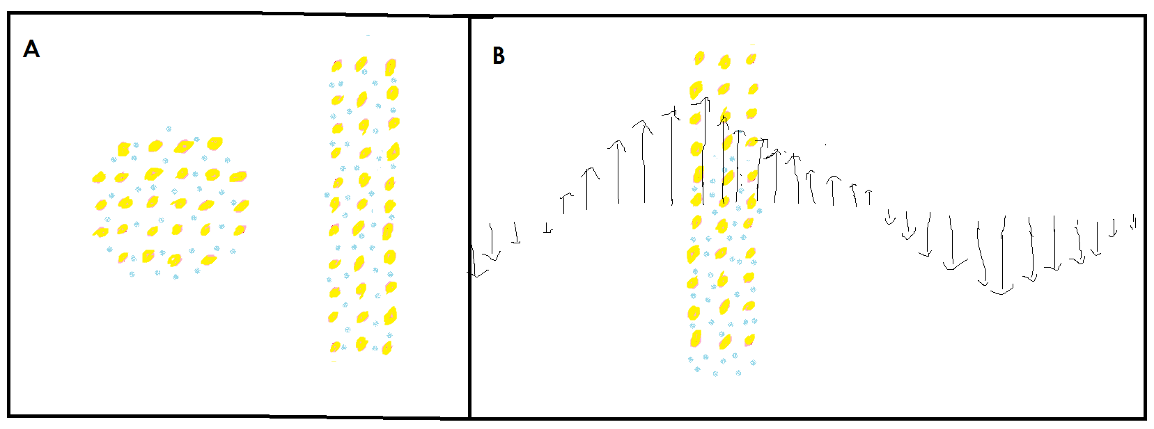

Figure 2. Gold Nanoparticles. (A) A diagram of gold nanoparticle, which can be made in different shapes. The gold dots represent the gold atoms, which contain the positively charged protons. The blue represents free electrons. Although the diagram does not show many atoms, a real gold nanoparticle contains roughly 100 million gold atoms (but atoms are so small that the whole gold nanoparticle is still microscopic). (B) We show a snapshot of a gold nanoparticle as it is exposed to light. At this moment in time, the electric field of the light is pushing the electrons toward the bottom of the nanoparticle (the electric field pushes negatively charged particles in the opposite direction from the direction of the electric field arrows).

What To Do
The activity below will teach you how gold nanoparticles work. In a gold nanoparticle, there are electrons, which are negatively charged, and protons, which are positively charged, so the electrons and protons are attracted to each other. That means if the electrons are pushed away from the protons, the electrons will spring back toward the protons. The electrons overshoot the protons and then turn back toward the protons and overshoot again and again, just like a vibrating spring. In this activity, you will use a spring to mimic the oscillation of the electrons in a gold nanoparticle.

  - Tape a meterstick to the wall, oriented vertically with the bottom of the meter stick at the floor.
  - Attach the mass to the bottom of the spring and secure it tightly with tape so that the mass cannot fall off the spring even if the spring is moving quickly.
Step 2.

Follow the instructions below and fill in your answers to the questions as you do the experiment.

Procedure and Analysis Questions
Hold the spring close to the meterstick and let the mass dangle down. With a piece of tape, mark the meterstick at the spot where the mass is dangling down – this is the mass’s resting position. While holding the top of the spring still, pull the mass down by 5 cm away from its resting position and let the mass go. Count the number of oscillations that occur in 10 seconds. (Note: One oscillation is when the mass goes from the lowest point to the highest point and back to the lowest point). You should have one person count the oscillations while the other person looks at the stopwatch. The stopwatch person should start the stopwatch as soon as the other person lets go of the mass.
- Based on the number of oscillations you counted, what is the frequency of oscillation?

- What is the amplitude of oscillation (i.e. how far from the resting position does the mass go)?

Repeat the above steps, but this time pull the mass down by 10 cm and let it go.
- What is the frequency and amplitude of oscillation this time?

- Why doesn’t it take longer for the mass to make a full oscillation when you pull it down further? (Hint: the mass is not moving at a constant speed. Think about acceleration).

Every vibrating object (such as a spring or a guitar string) has its own frequency at which it always oscillates after you pull it and then let it go. This is called its natural frequency. The natural frequency depends on the object. For example, stiffer springs oscillate faster (i.e. have a larger natural frequency) than looser springs. For a particular spring, it doesn’t matter how far you pull the spring, when you let it go, it will always oscillate at the same frequency. The same is true for other oscillating objects.

Nanoparticles come in different shapes, including elongated particles called nanorods. Gold nanorods behave much like springs (see Figure 1): after the electrons are pushed toward one end, the electrons swing back toward the other end and keep going back and forth at a particular frequency, like a natural frequency in springs.

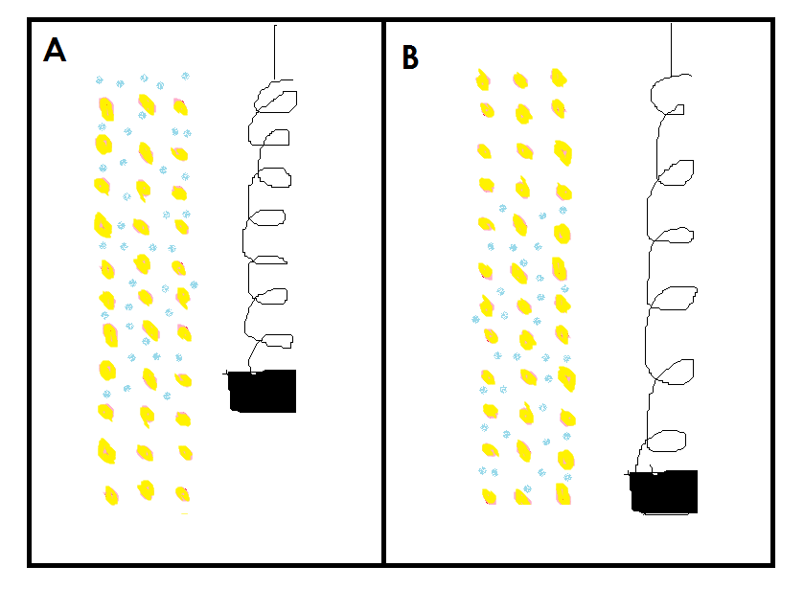
Figure 1: Gold Nanorods are Like Springs. The gold atoms are shown in yellow. (A) shows the electrons (shown in blue) near the top end, like a mass on a spring that has gone up. {B) shows the electrons near the bottom end, like a mass on a spring that has gone down.

Now you will use the spring to understand in detail what happens to electrons in a gold nanoparticle when they are exposed to light. This time, you won’t pull the mass down and let it go. Instead, you will repeatedly move the top of the spring up and down. When you move up, the spring pulls the mass upward. When you move down, the spring pushes the mass downward. This is similar to how the light wave’s electric field pushes the electrons up and down in the gold nanoparticle.

The spring can move a lot, so put on safety goggles and hold the spring far from your face so it does not hit you. Hold the spring high above the floor so it does not hit the ground. Repeatedly move the top of the spring up and down at the frequency you wrote down in question 1 (i.e. the natural frequency). When moving the top of the spring, move it up to 2 cm above its starting position and then down to 2 cm below its starting position and repeat this about 10 times in a row - in other words, do 10 oscillations. (You can watch the stopwatch to make sure you are approximately moving the spring at the right frequency). Notice how your hand is moving in sync with the mass. Also notice how even though you are only moving your hand 2 cm in either direction, the mass eventually moves much more than 2 cm.

- What is the final amplitude of oscillation? (Measure from the resting position down to the lowest point where the mass went).

The frequency at which you are moving the top of the spring up and down is called the driving frequency because you are driving (forcing) the spring. Repeat the previous step three times, but each time move the top of the spring at a different frequency. Use the following driving frequencies: twice the natural frequency, three times the natural frequency, and half the natural frequency. Carefully observe the motion of your hand, the spring and the mass.
- For each driving frequency, what is the final amplitude of oscillation?

- a. Which driving frequency gave rise to the greatest amplitude of oscillation?

b. Notice how this driving frequency caused the mass to move the largest distance every second - in other words, it caused the mass to have the largest speed. Explain why this driving frequency led to the greatest amplitude and speed. (Hint: Watch the mass as you push the spring, and compare your hand’s motion and the mass’s motion). Drawings/diagrams are the best way to explain science. Draw a quick diagram along with your written explanation.

- Which driving frequency gave rise to the smallest amplitude and slowest speed? How come?

- As you saw, a particular driving frequency caused the spring to have a large amplitude. We call it resonance when an oscillating object has a large amplitude as a result of being pushed by a particular frequency. The electrons in gold nanoparticles also experience resonance. Use your understanding of springs, gold nanoparticles and light to answer the following question. For parts a and b, draw quick diagrams along with your written explanations.
a. Why do the electrons in a gold nanorod oscillate with the largest amplitude and largest speed when they are exposed to light with a frequency that is the same as the natural frequency of the electrons’ oscillation?

b. Why is it important to make the electrons move as fast as possible when treating cancer?

